**Project Title: Visual UI for MARTA**

**Team Members:** Daryl Bilderback, Limbert Bontigao, Gene Cannella, Thomas Gentle, Tyler Maran, Nic Branker

**Project Description:** STAGE1: Our Team wants to have a Graphical Map of the MARTA Rail system, showing all Trains, incoming Trains, Train Delay notifications, etc.

Sketch of Final Project:

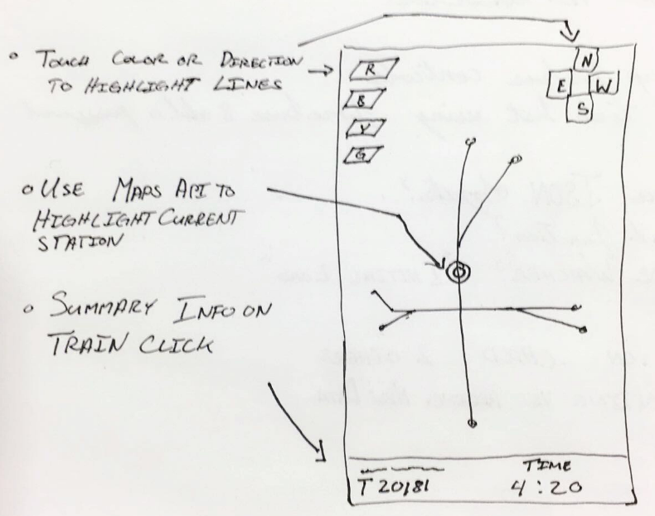**APIs to be used**: MARTA API, Google Maps API

Rough Breakdown of Tasks:

1. Create UI
2. Figure out User's Location by interfacing Google location to assign closest MARTA Station
3. Call the MARTA API to populate a Database (ex. Firebase)
4. UI will call the Firebase Database to display the Graphical interface
5. Upon station select, the user will be given summary information on upcoming trains and a visual update

**First Steps:**

1. Initialize a firebase database to store the data from Google Maps and Marta API
   1. Nic
2. Begin constructing the basic UI outline
   1. Daryl, Limbert, Gene
3. Build basic HTML to pull data from the database
   1. Tyler
4. Store user preferences
   1. Thomas

**Stretch Goals:**

* Data analytics for operators
  + Number of times each train is late or out for maintenance
* Pull late/on-time/early train statistics and push a “likelihood of on-time” indicator for each train
* Sell to GDOT for a piece of that $1.2bln in new funding Marta just got